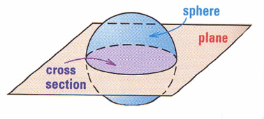
Unit 1 Cross Sections and Rotations
3-Dimensional figures can be cut by planes. When you cut a 3-D figure by a plane, the result is a 2-D figure.
A horizontal cross-section of a cone is a .

A vertical cross-section of a cone is a _____________________.

Examples: DESCRIBE the shape resulting from a vertical, angled, and horizontal cross-section of each cylinder.
VERTICAL SLICE: The cross-section is a _____________________

ANGLED SLICE: The cross-section is an __________________

HORIZONTAL SLICE: The cross-section is a _____________________

Practice Problems: DESCRIBE the shape resulting from each cross-section.

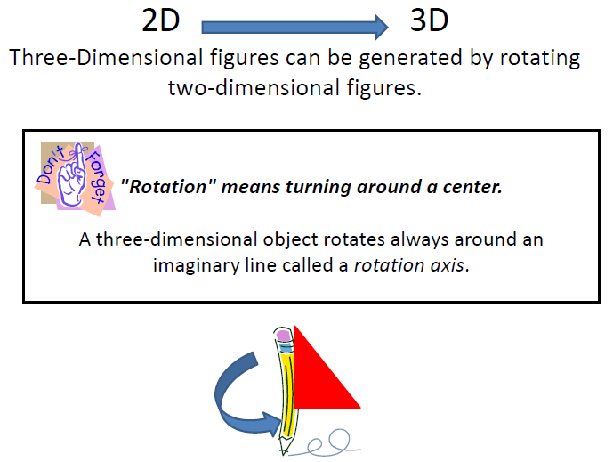

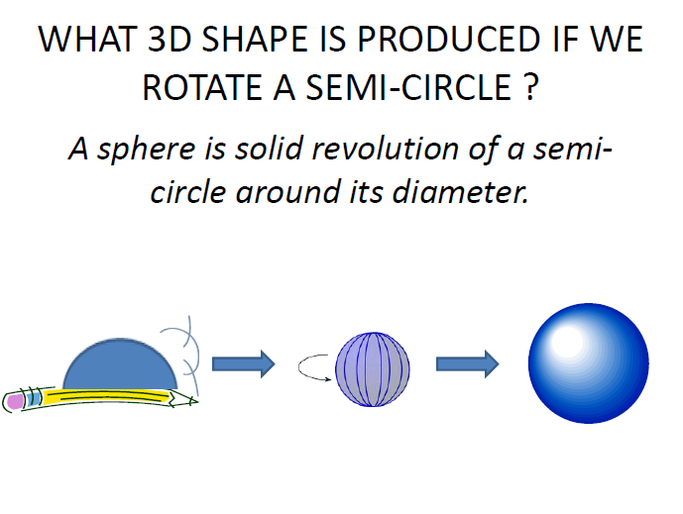
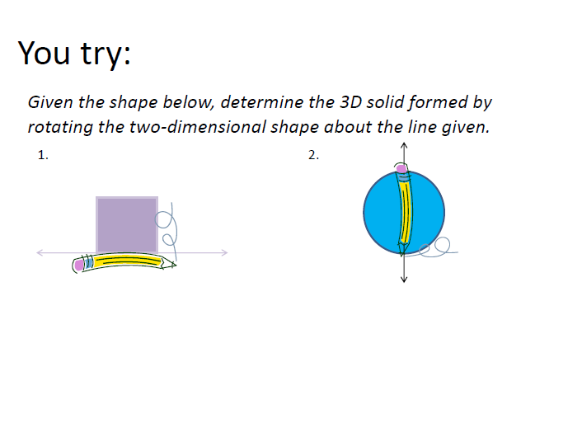

Application Problem 1: Given a cylinder with diameter 16cm and height 32cm, find the area of a cross section that is parallel to its base.

Application Problem 2: If an equilateral triangle with perimeter 36in is rotated, find the volume of the 3-dimensional shape that is formed.

