Literacy Activity #2
“My Life Story Board”
It’s your rime to create your autobiography. Instead of writing it out in paragraph form you are to create a story board. This will count as a formal grade and is due Friday September 9, 2016. I expect you to be creative and include the items listed below. You must include two hand drawn pictures and have color on your story board. I will provide you with the copy paper to complete your work. I have provided an example below for you as well.

1. Quote and its importance to you
2. Influential person in your life and why
3. Hobbies
4. Career Goals
5. Personal Goals
6. College you would like to attend
7. Favorite Author or Book
8. Legacy that you would like to leave behind
9. Pet Peeve
10. One Word that describes you
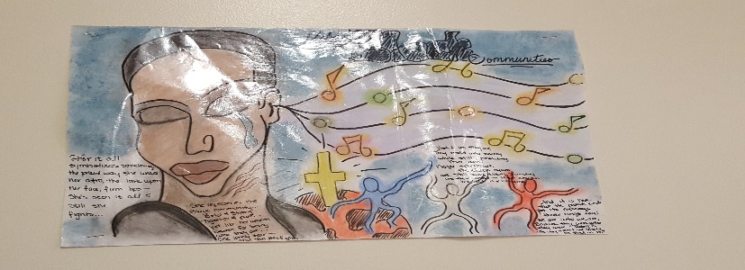
Rubric
On Time 10pts
Creativity 10pts
Color 5pts
10 Required Items 75pts
Total 100pts

