**Circles HW #3**

**1.** What is the area of a circle with a diameter of 100 feet?

**2.** What is the area of a circle with a diameter of 9.2 centimeters? Round your answer to the nearest hundredth.

**3.** What is the area of the circle? Round your answer to the nearest hundredth.  
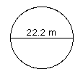

4. What is the circumference of the circle? Round your answer to the nearest hundredth.  
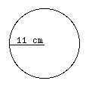

5. What is the circumference of a circle with a diameter equal to 4 centimeters?

6. The circumference of a circle is 26.376 meters. What is the diameter of the circle?

7. What is the circumference of the circle? Round your answer to the nearest hundredth.  
  


|  |  |
| --- | --- |
| # 8 |  |