It’s My Business
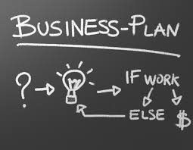
This project will allow you to use your entrepreneur skills as well as your math skills to experience what it is like to open and run a business. You will work in groups to complete the task and randomly choose a business to open. You must have the following positions in your company: 1.) Chief Executive Officer (CEO), 2.) Treasurer/Accountant, 3.) Secretary, 4.) Promotions/Marketing Manager. You must also create a business plan, Product (3-d model), Logo, and Website for your company. A business does not run without revenue. Think about how you are going to get money to make money. How are you going to gain investors, stock, and market your company? How much are you charging for your product and will it be enough for you to not go bankrupt? This project will be a great way for you to learn about the different aspects of running your own business. Have fun, be creative, do your research and work together to meet the deadlines. You will have limited class time to complete this project, therefore you may want to exchange numbers with your group members and delegate task. Below you will find the things that I am looking for as it pertains to each section of your project. The deadline and rubric for each section will be given/posted on website at a later date.

Business Plan
-Executive Summary, General Company Description, Products/Services, Marketing Plan (Product, Customers, Competition, Promotion, Promotional Budget, and Pricing)
Logo
-Creative, Include picture and Company Name
Product
-Creative, 3-D Model
Website
-Business Name, Logo, Group Members Name and Picture, Business Plan, Picture of Product, Marketing Strategies, Competitive Analysis table.

Marketing
-Marketing Material (Flyer, Brochure, Business Card, Postcard, etc)

