**Points of Concurrency Notes**

|  |  |
| --- | --- |
| Point | Lines that make it |
| Orthocenter | 3 Altitudes |
| Centroid | 3 Medians |
| Incenter | 3 Angle Bisectors |
| Circumcenter | 3 Perpendicular Bisectors |

***Acronym to remember points of concurrency***

**O**verly **A**ggravated **C**entipedes **M**et **I**nside **A** **B**ookstore and **C**aused

**P**andemonium and **B**edlam.

|  |  |  |  |
| --- | --- | --- | --- |
| Pont of Concurrency | Acute Triangle | Obtuse Triangle | Right Triangle |
| Orthocenter | Inside | Outside | On |
| Centroid | Inside | Inside | Inside |
| Incenter | Inside | Inside | Inside |
| Circumcenter | Inside | Outside | On |

******Things to KNOW******

1. The ***incenter*** of triangle is equidistant from the sides of the triangle.
2. The ***circumcenter*** of a triangle is equidistant from the angles of the triangle.
3. The ***centroid*** is two thirds (long line) and one third (short line) of the distance from each vertex to the midpoint of the opposite side. The shorter line is half of the longer line.
4. To ***inscribe*** a circle about a triangle, you use the incenter.
5. To ***circumscribe*** a circle about a triangle, you use the circumcenter.

Name the point of concurrency for each

1. Angle Bisectors of a Triangle _______________________
2. Medians of a Triangle _________________________
3. Altitudes of a Triangle ________________________
4. Perpendicular Bisectors of a Triangle _______________

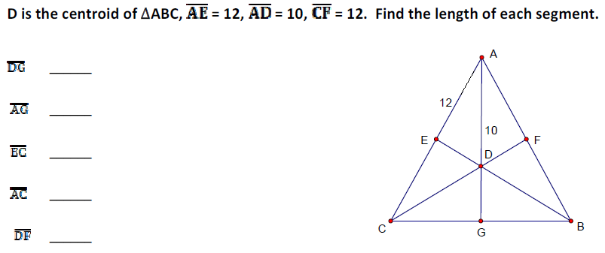

Point G is the centroid of triangle ABC. Use the given information to solve for X.

BG = 4x + 5 and DG = 3x

EG = 2x – 8 and EC = 3x + 3

GF = 3x – 2 and AG = 5x

